ASCI VALUE :

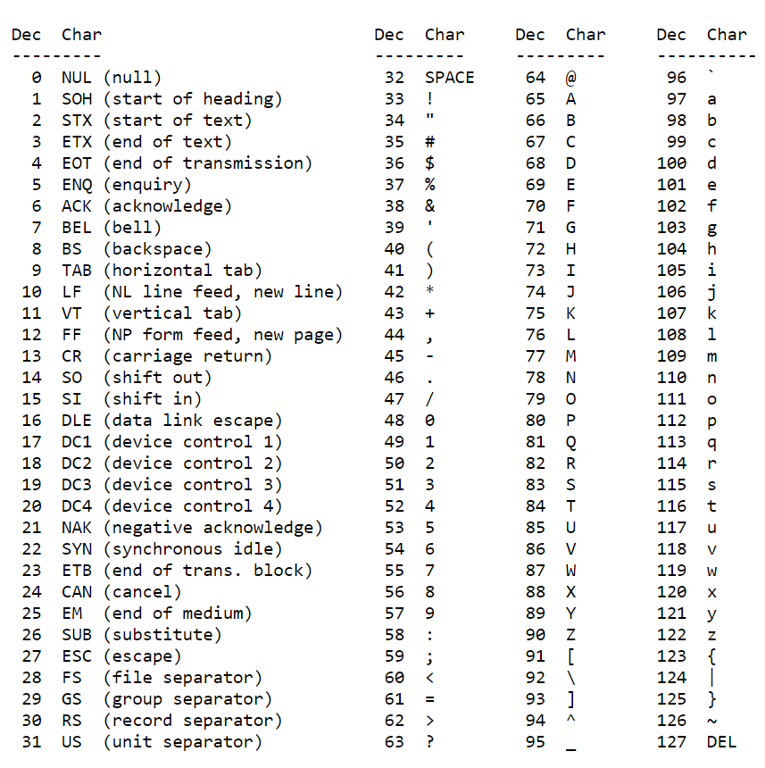

//ASCI VALUE

//THIS CODE IS WRITTEN BY AYUSH

public class PrintAsciiValueExample1

{

public static void main(String[] args)

{

// character whose ASCII value to be found

char ch1 = 'a';

char ch2 = 'b';

// variable that stores the integer value of the character

int asciivalue1 = ch1;

int asciivalue2 = ch2;

System.out.println("The ASCII value of " + ch1 + " is: " + asciivalue1);

System.out.println("The ASCII value of " + ch2 + " is: " + asciivalue2);

}

}